Team: Alpha-Bravo

Members: Anthony Martinez (Team Leader), Dustin Chhum, Howard Cho, Luis Rodriguez

Sequence Diagrams







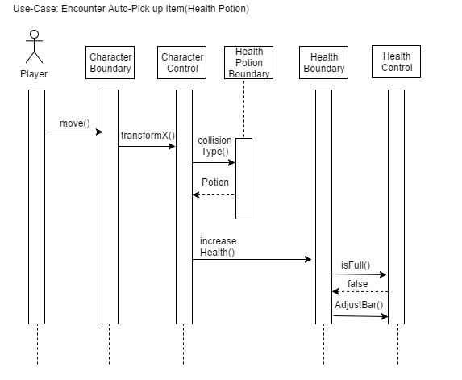

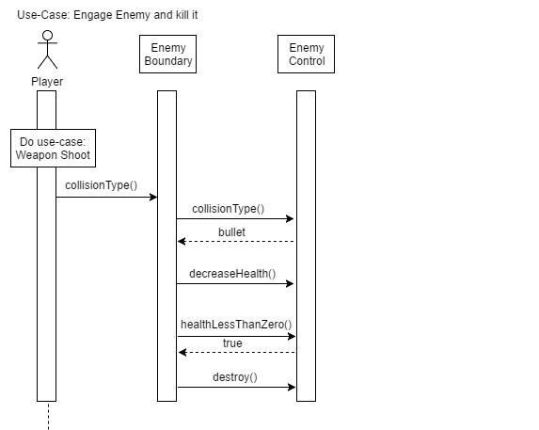

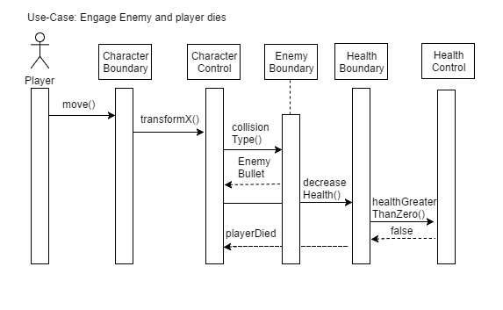

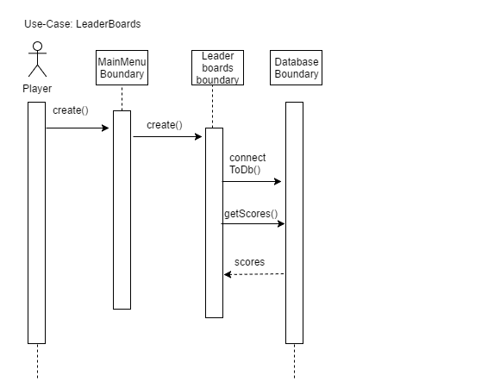

SD- Start a Game.png

SD- Load Game.png

SD- Exit From Menu.png







